Sprint2_Assignment1

Repo URL - <https://github.com/vaithimarou/msbatch3-order-management>

2. Screenshot for successful start of services/ execution of services.

3. Evidence screenshot for request to end points from Postman.

4. Build of services should be possible with maven. Provide successful build screenshot for same.

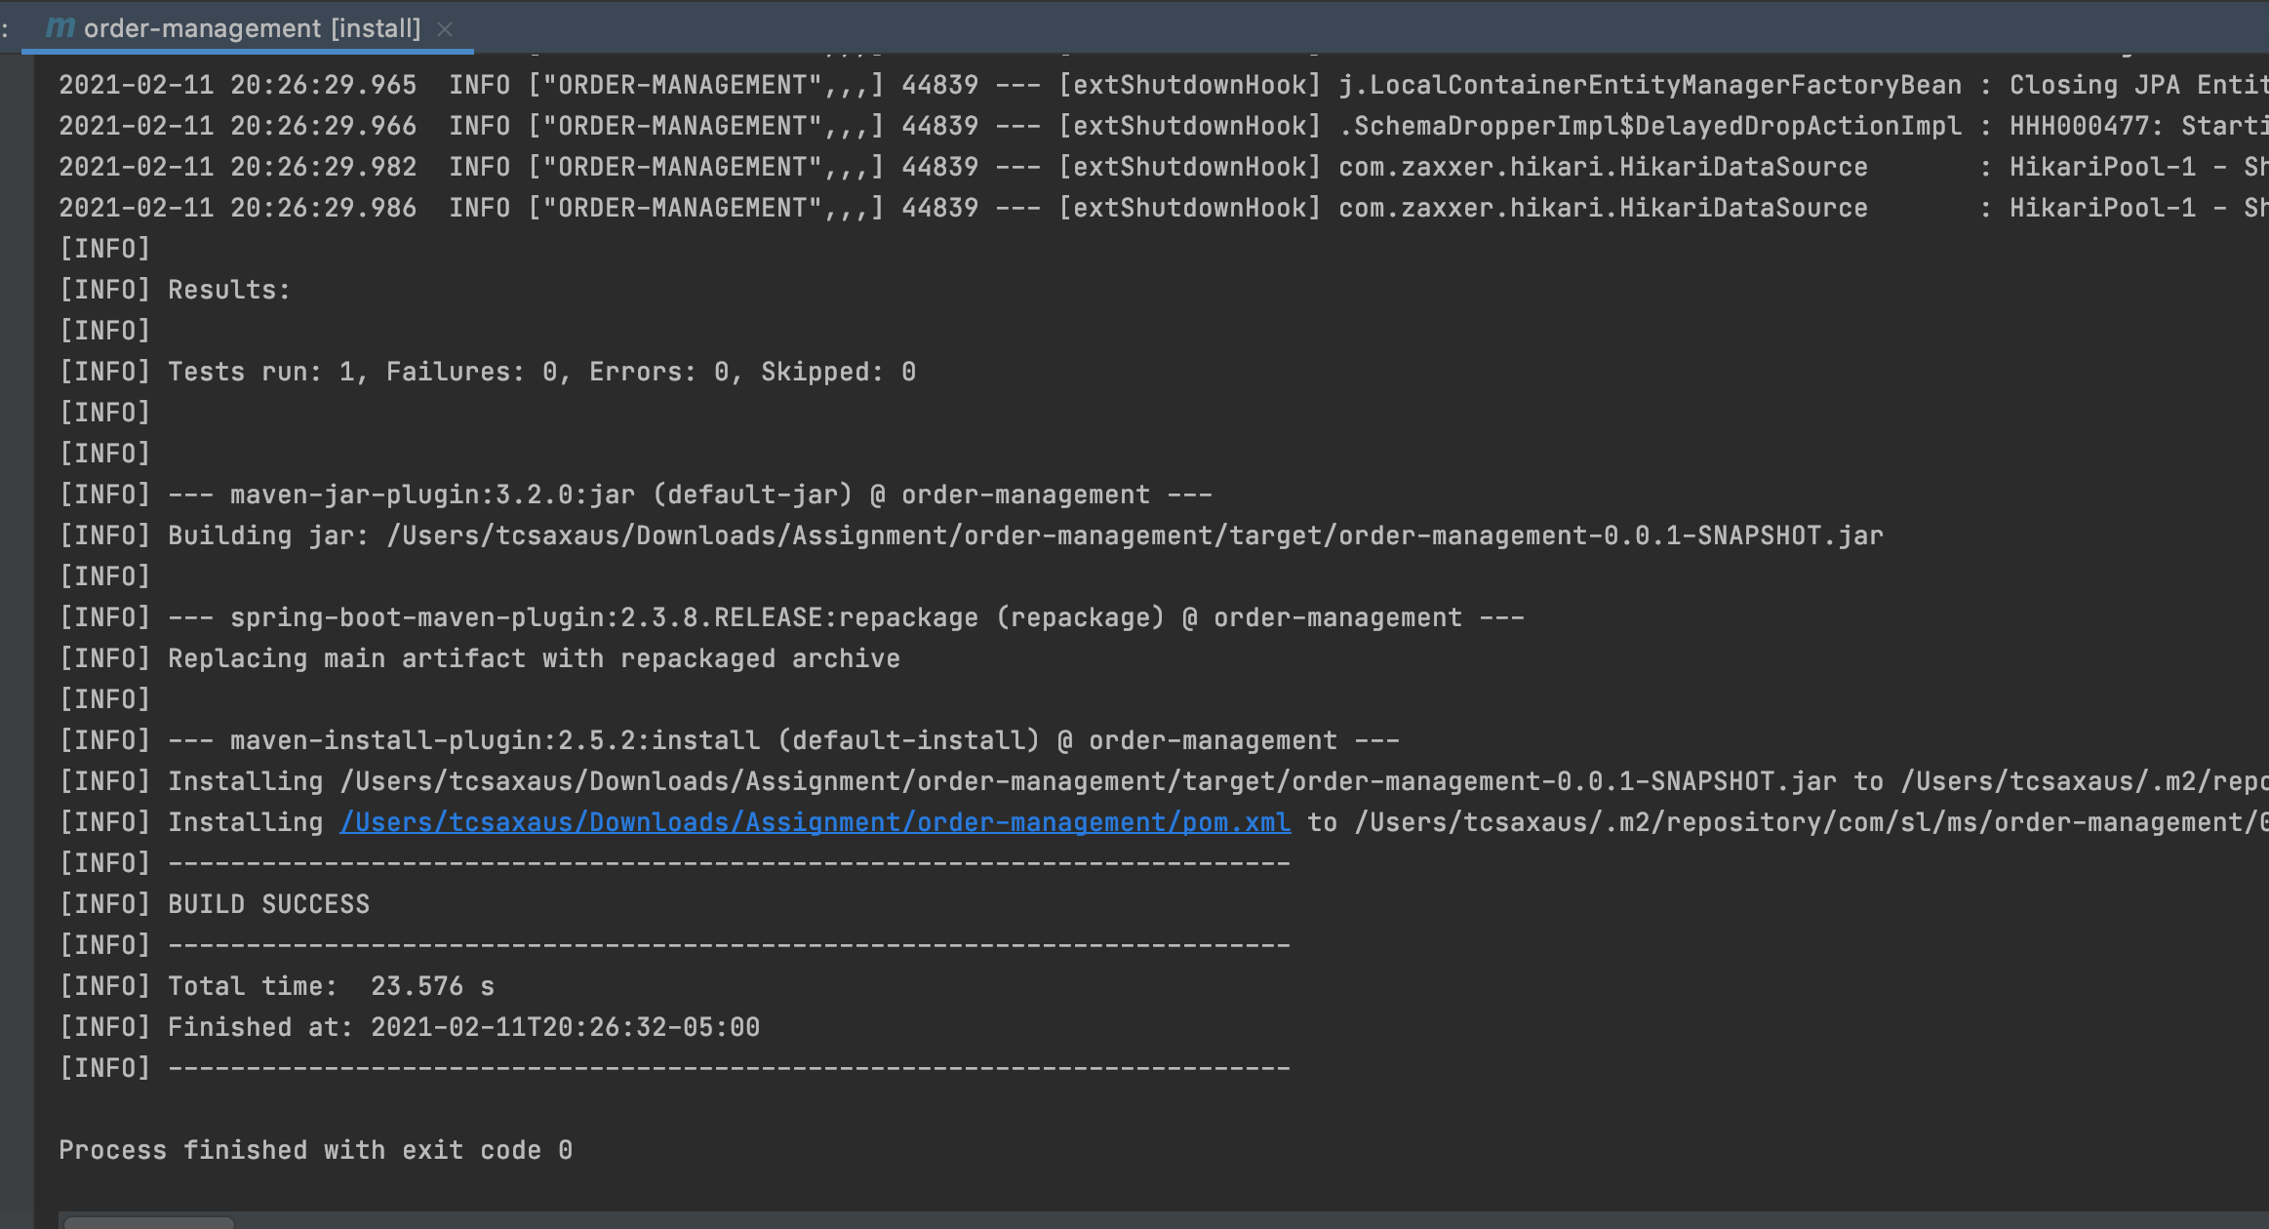

5. Evidence for additional task completion by executing /dev end point in postman and screenshot for yml config.

6. Verify the end point via POSTMAN.

Sprint2_Assignment2

Repo URL - <https://github.com/vaithimarou/msbatch3-inventory-management>

2. Screenshot for successful start of services/ execution of services.

3. Evidence screenshot for request to end points from Postman.

4. Build of services should be possible with maven. Provide successful build screenshot for same.

5. Evidence for additional task completion by executing /dev end point in postman and screenshot for yml config.

6. Verify the end point via POSTMAN.

